**PO (Purchase Order):**

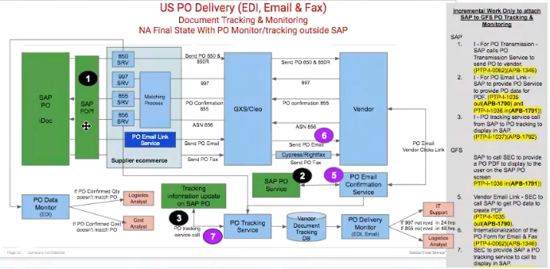

**Marked as (1) in image:** SAP doesn’t really have any tracking, and notification to Cost Analysts /Business Team related features which the current PO system already has.

POAsn and POAck services are going to be cloned out of the PO repository and put into a new repository under **Supplier Ecommerce (SEC)**. The functionality of this Supplier ecommerce will be to integrate with SAP.

SAP PO will create POs and send an SAP proprietary XML called IDoc to SAP POPI (or Magic Box, tool or additional layer within SAP for transforming and translating data in and out of SAP).

SAP POPI will convert the SAP iDoc to a new **PO transmission XML**. Additional fields will be added to it as well. We will create a service that SAP can call to provide us with PO transmission XML for doing all three transmission operations: EDI, FAX and EMAIL. The current service accepts only Java objects. Needs to be updated to accept XML.

We will have to add new fields to the PO transmission XML as well. Some of these additions are going to be language related (French, Spanish etc.)

The current output XML can be viewed below in the current PO application when user clicks “View Output XML” on an existing Purchase Order.

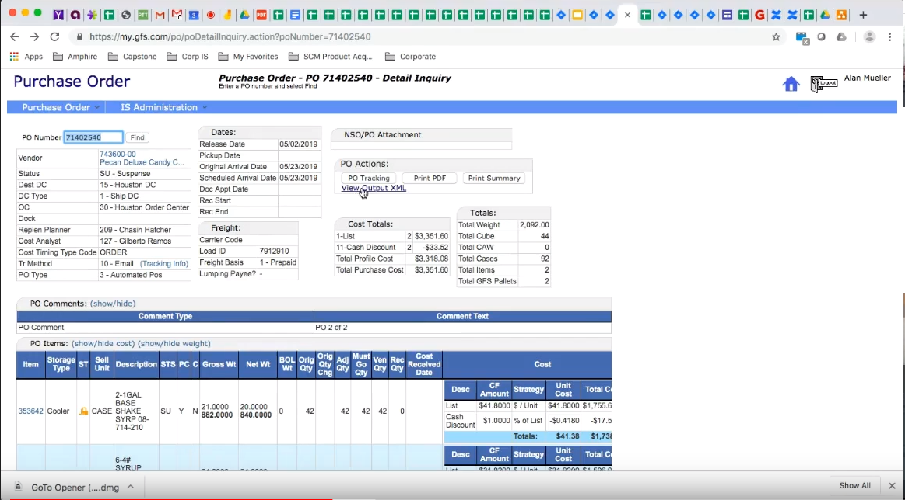

**Marked as (2) in image:** When Vendor receives an email communication about PO from GFS, and clicks on the link provided in the email, the details of the PO need to be fetched and displayed to the Vendor as a PDF.

SAP will provide an email service which will provide the exact same PO Transmission XML, which the existing PO Email Confirmation Service will have to be modified to be able to consume, in order to display PO details to the Vendor correctly in PDF form.

**855 EDI Confirmation Message:**

EDI Vendors will send us back a confirmation, specifically 855 confirmation within 48 hours of receiving an EDI transmission message for the purchase orders.

We can get to know any Cost and Price discrepancies through this confirmation message. Cost differences will be sent to Cost Analysts.

Once they send us back the confirmation, we need to look up the Purchase Order in the SAP system, which will provide us the PO transmission XML through a service. We need to match up the items within the 855 XML and the PO Transmission XML using a series of matching codes: GFS Item Code, then the Vendor Item code etc. and return a SAP PO Line Number back to SAP. In the legacy system, we were only matching up the Item Code as of now.

If no match is found, a notification is to be sent to Buyers/Cost Analysts that either a new item is being added or an existing item is being replaced. In this case, SAP PO Line Number will not be available.

Legacy PO Test Cases are available which we can use to re-test the entire PO system once above changes have been updated.

**856 EDI Confirmation Message:**

This will act as a final confirmation from the Vendor. At this point, Vendor is aware of the Items shipped. We will know if there was a last minute substitution.

All this will have to be done by SEC system and not PO system and these two systems will be operating independently.

Tracking information from UPS and FedEx is also available for GFS which should be transmitted back to SAP.

**NSO:**

Vendor Dropship NSO Orders can be created using NSO, Dobbin, and EPO (Online Ordering) system.

Using Dobbin, we can create GFS Warehouse orders as well. It is a desktop (Client Server) application.

Purchase Orders can be only for stocked items, since non-stock items will be directly sent from Vendor to Customer as a Vendor Dropship order.

**PO Tracking Information:**

SAP will provide tracking information as well. We will provide a service to SAP and provide them with the tracking information.

**Panera:**

Panera is an EDI related enhancement specific to one of the GFS clients Panera Bread. Some additional services have been created for this client.

**POASN Service:**

Advance Shipment Notice sent to vendor saying these many orders are on your way,which the Vendor can acknowledge using POACK Service.

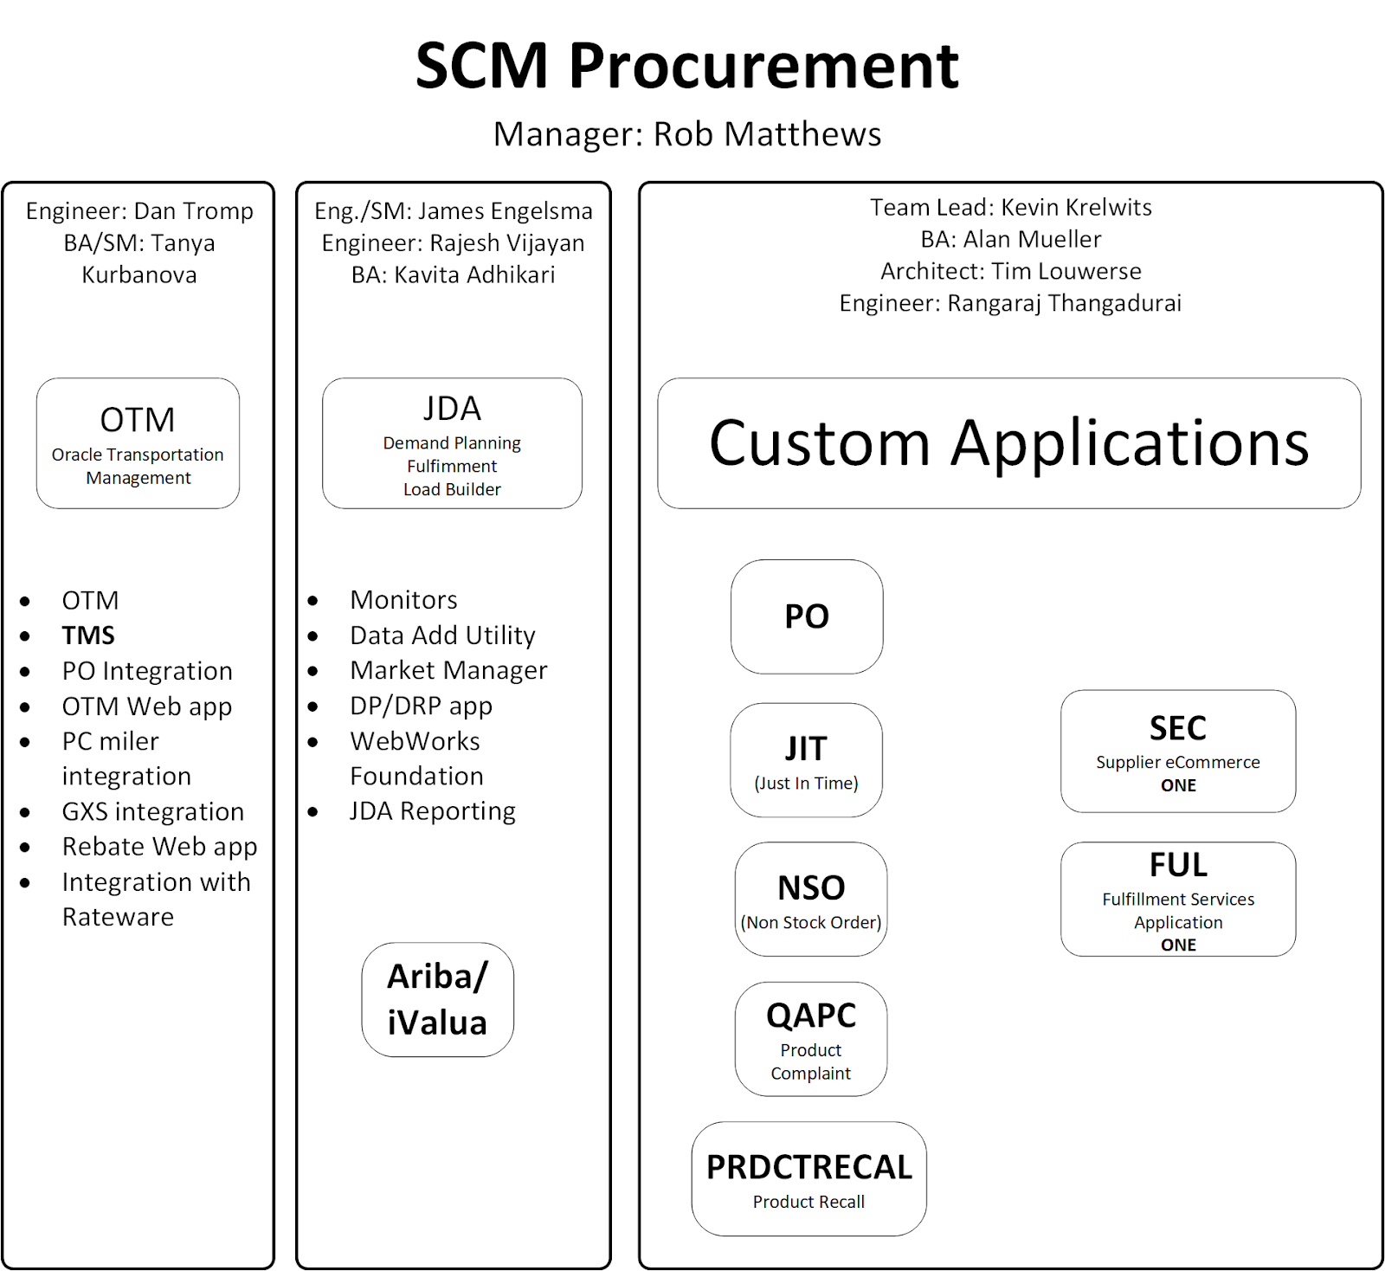

**Supply Chain Management:**

SCM, according to Tech Target, “is the broad range of activities required to plan, control, and execute a product’s flow, from acquiring raw materials and production through distribution to the final customer, in the most streamlined and cost-effective way possible.”

**Procurement:**

Procurement focuses on finding the right suppliers for the goods and services you need to manufacture your own products or deliver your own services. As such, procurement is the process of getting possession or obtaining something.

Other Applications:

**JIT (Just In Time):**

When does the order comes to JIT?  Answer: Order will be in JIT with 2 conditions must satisfied:

1. Orders (from Online Order) must be released by OMS. **Note that:** Customer profile (Skip Day or Next Day) or Vendor (JIT Program) Lead Days have nothing to do with when orders come to JIT system
2. That JIT Program (JIT) must still be active (in Opened window) for that day. To check program opened window, go to Program Management > View/Maintain, then enter Program number > Click on Work Order Schedule Configuration tab. Please refer to below screenshot; in this case, this program 41 is opened from Mon to Fri 5am to 1pm.

- This link seems to be important: <https://confluence.gfs.com/confluence/display/CorpISCRMGFSeCommerce/Overview+JIT+Process+for+O2C+Testing>

- We are able to open JIT application through mysit.gfs.com. On the Home Page -> Business Application -> Just In Time

Connection between JIT and PO (Images 1, 2) below. Seems like JIT can trigger the creation of PO Order.

Image 1:

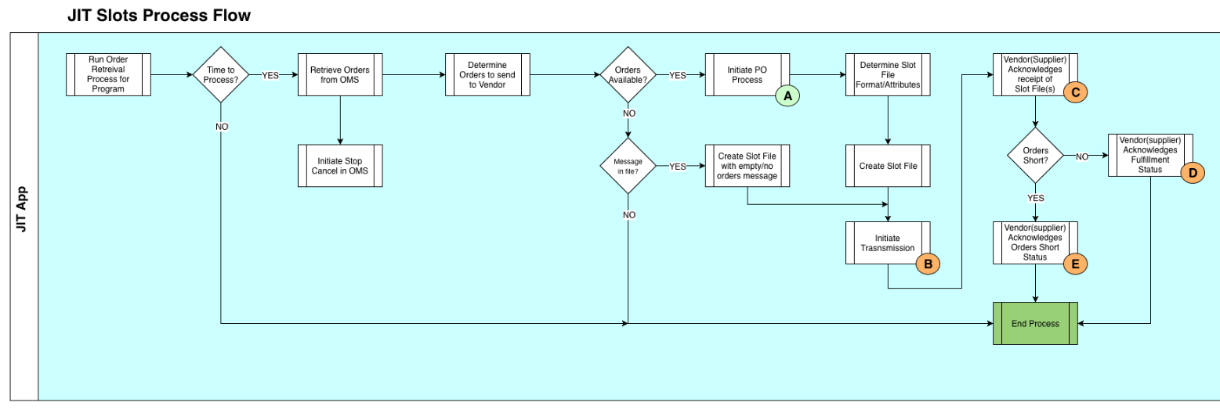

Image 2:

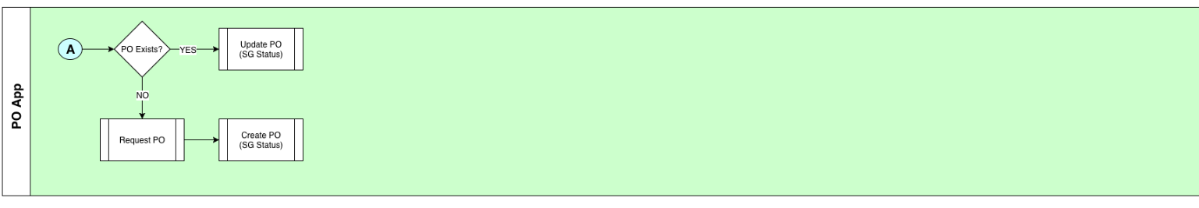

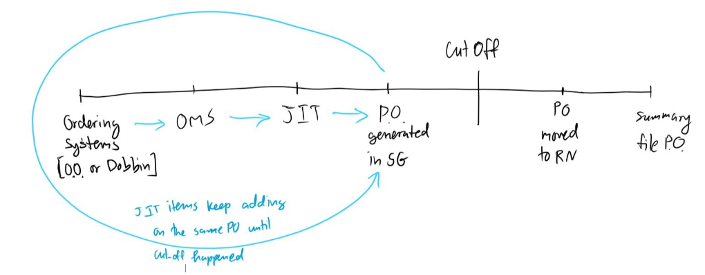

**Product Recall:**

Product recall instructions PPT: <https://docs.google.com/presentation/d/1yaE_1Ci-1pDMJfmwTQApuLBoKEsHWy_1EinSVCGAuHU/edit#slide=id.g1972616f31_0_15>

**Fulfillment Services:**

Fulfillment services are being automatically called when delivery related dates are being calculated by the PO system.